**Contents**

1.UX Designer.

2.UI Developer.

3.Full Stack Web Developer.

4.Technologies.

5.Software we are going to use.

HTML

1.Web Page.

2.Web Site.

3.URL.

4.Mark Up Language.

5.HTML.

6.HTML Document Structure.

7.Creation and view of Sample Web page.

8.Inline and Block Level Elements.

9.Paragraph tag

10.Heading Tags

11.Horizantal Ruler

12.div

13.span

14.Image

15.Hyper Link

16.List

17.Table

18.HTML Input Elements

19.Form

20.HTML Special Character.

1. **1.UX (User Experience) Designer**:- The UX designer makes mock up’s as per requirements. The mockups are showed to client. If client accepts then mockup will be given to UX developer for actual Implementation.
2. **UI Developer:**- The UI developer is also called as ‘FRONT END Developer ‘ or WEB Developer. The Input to UI developer is mock up’s . He writes programs to design web pages.
3. **FULL STACK WEB Developer:-**A full stack web developer is a person who can develop both client side applications and server-side applications.

**(or)**

Whoever the person have both front-end development skills and Back-end development skills is called Full stack web developer.

**4**.**Technologies:-** To Become UI Developer , The following technologies have to be learned.

* HTML4&5
* CSS2&3
* JAVA SCRIPTS
* ADVANCED JAVA SCRIPTS
* JQUERY
* ECMA 6
* BOOTSTRAP 5

**5.Software we are going to use**:

• Browsers: Internet Explorer, Google Chrome, Safari, Firefox etc.

• Editors :Sublime Text, Visual Studio Code(Microsoft’s) .

• Repository: GitHub.

**HTML**

1. **Web Page:-** A web page is a document. A web page contains text, graphics, hyperlinks to other web pages and files, audio, video or .. etc. The web page is accessed by URL. The web page is written in HTML language. The web page can only be in browser window.

Types of Web pages:- There are two types of web pages.

* 1. **Static Web Page**:- The content of this web page will remain same for all the request irrespective of request generation time or input values to request.

Example:-

1. About us page
2. Wiki pedia page
3. Terms & conditions page.

In static web pages, Pages will remain same until page designer/page owner changes it manually. The information which is on static web page is rarely changed.

when we want to only display small amount of information(upcoming- event ,contact info, description about company …etc) about our business , we choose development of static web page.

* 1. **Dynamic Web Page**:- The content of this web page will be changed based on input values to request or time of request generation. On Dynamic web page,

We see some fixed/constant content and dynamic content which is changed time to time or based on input values.

Examples:-

1. Any login page:- when user give wrong credentials(inputs) ,we see the error message dynamically in red color on login page.
2. Stock market trading web site web page.
3. Live IPL game scoring web page.

The following websites have dynamic web pages.

Any E-commerce sites , to-do sites..etc.

1. **Website:-**  A web site is a collection of interlinked web pages. All web pages have unique address. All pages share common domain name. The website is published on at least one web server.

**3.URL:-**It is address format. It specifies address of resources on web.

3.1.URL Format:-



**A.Protocol:-**It is a set of rules followed by two parties who wants participate in communication. There are two types of protocols:

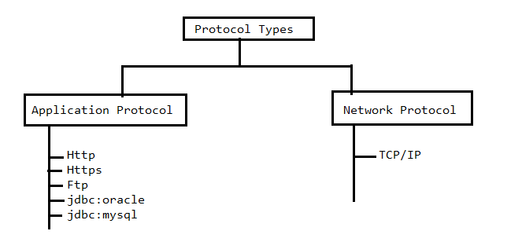

A.1.NetWork Protocol:- For communicating two computers over network with each, Network protocol gives set of rules.

A.2. Application Protocol:- Application protocol gives set of rules to get interaction between two applications of same computer or two different computers of network.

Note:- If two applications are in two different machines of network then applications uses application protocol over the network protocol for communication.

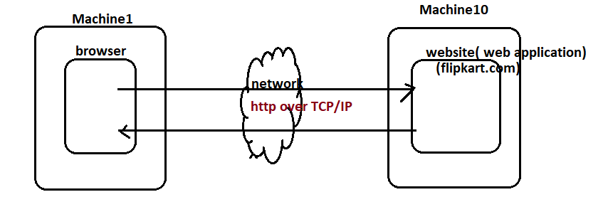

Examples To Protocols: https:// , ftp://, http://, file:// , …etc.

**SubDomain:-**  A sub domain consists of any words. Usually the most common sub domain is www. It indicates that web site is accessible through internet and uses the specified protocol for communicating.

**Domain Name:-** Domain name is unique and that represents IP address of server. The website/web application generally depolyed in server computer. The server computer is somewhere on internet or intranet. The server computer has unique IP address. That is represented by domain name. This domain name is translated to IP address By DNS(Domain Naming Service).

Advantage:- Daily, user visits several web sites. Remembering the all websites deployed web server IP addresses is very difficult. Therefore They are mapped with Domain names. Remembering domain names are very easy.

EX:-facebook , google , flipkart …etc are examples to domain name.

**domain type(Top Level Domain):** It specifies that Zone where domain name is used

EX:-.com.,.gov,.edu,.net,.org are domain types.

**Port Number:-**we use different hardware ports to connect external devices to computer.

Example to Hardware ports:

1. USB Port

2. Printer port.

3. console port.

…etc.

In windows, total 65535 ports are available. In that ,From 1 to 1025 are reserved for OS services. These OS service run on top of one of these port.

Rest of the ports are used by external softwares like (oracle,tomcat,…etc). while installing the external software, default port or any other port is allocated to it. On top of allocated port , The external software will run. Every port is identified by “Unique number”.

Example:

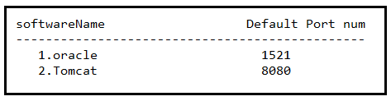

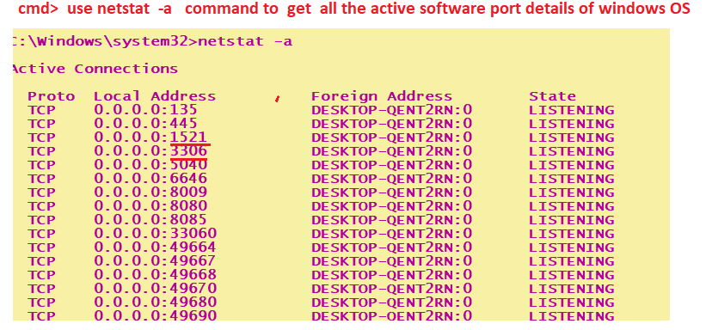

Socket:- socket number is <IPaddress/HostName>+port number.

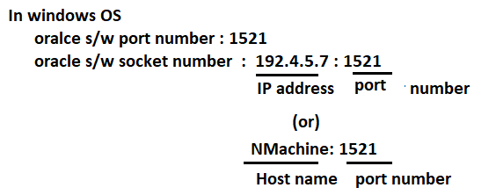

**Resource Path:-** The resource path begins with root directory of website/web application deployed in web server.

**Query String:-** The query string is separated using (?) from other part in URL. It is optional. It have one or more than one pair. Each pair consists of parameter name and URL. These pairs are separated by (&) .

Ex:- name=suku & age=41.

**3.2.Types of URLS:-** There are two types of URL’s.

**a.Absolute URL.**

**b. Relative URL.**

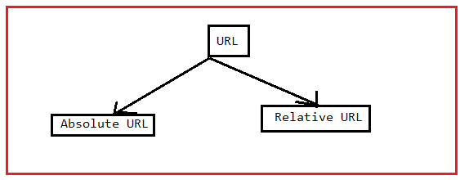

1. **Absolute URL:-** The URL contains the complete address of component is called Absolute URL.

Example:

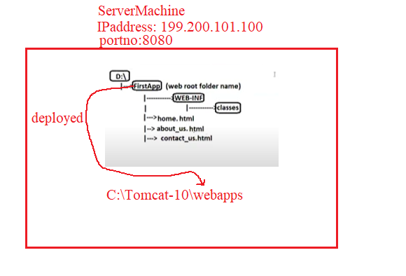

* + In the context of website/web application , The absolute URL begins with protocol and ends with query string.

Examples:

1.https://localhost:8080/FirstApp/home.html

2.http://localhost:8080/FirstApp/contact_us.html

* + In the context of OS File System, The absolute path begins with drive name (c:/,d:/,…etc) and end with filename/Direcotry Name.

Examples:

1.D:\FirstApp\home.html

2.D:\FirstApp\contact_us.html

* + In the context of “resource path”, The absolute URL begin with deployed web application root directory and with component name.

Examples:

1. FirstApp/home.html
2. FirstApp/about_us.html
3. **Relative** [**URL**:-](URL:-) The url that contains address of component from current directory is called Relative URL.

when we move from one component(.html,.java) to another component(.html, .java), we should specify other component address in the form of relative URL. The other component address should be specified in the form of absolute URL because It kills WODA (Write Once Deploy anywhere) property of web application.

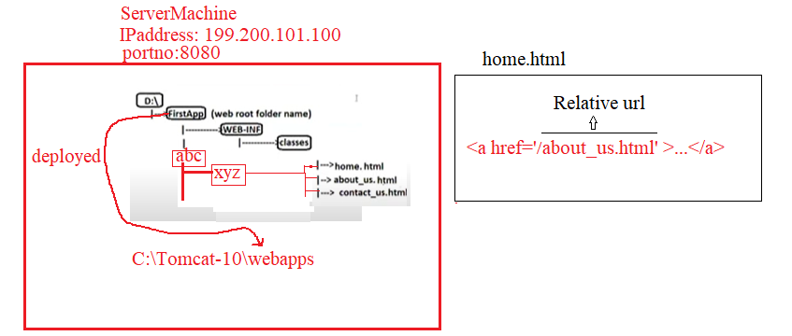

**Problem by specifying address as Absolute** [**url:-**](url:-)

< a href=” [http://localhost:8080/abc/xyz/about_us.html”>...</a](http://localhost:8080/abc/xyz/about_us.html)>

When you redeploy the web application in another server machine or you change port number , you can’t move from home.html page to about_us.html page.

Solution:

You have to change IPaddress or port number in every absolute urls in web application. This is time taking process.

**4. Mark Up Language***:*- Any Language that uses the tags to define content of web page is called **markup language.**

Example to markup language are : HTML , XML ,SGML.

**5.HTML4(Hyper Text Markup Language):-**

Hypertext is text which internally contains the linking features. The html is used for creating web pages. It have several predefined tags. Predefined tag means tag which is already defined and has fixed meaning.

Advantages & Disadvantages of HTML:-

Advantages:

* It is easy to use and learn.
* All browsers supports html.
* The other language code(css&js) can be integrated with html document.

Disadvantages:-

* It is very difficult to design attractive webpages using only html.
* Using Html, we can’t develop the dynamic webpages.
* We have to write a lot of code to develop simple/small website.

5.1)**Element:**-The element is component is Html Document.Starting tag , content and ending tag all together defines Element. The starting tag is mnemonic symbol for element surrounded by angle brackets. An end tag is indentical to start tag, except that symbol for end tag is preceded by forward slash.

Syntax:-<starting_tag_name attr-1 attr-2…attr-n >content</ending_tag_name>

The content is text ,another element,image …etc.

**5.2)Tag** :-The tag is instruction/keyword. It specifies that what type of content to be displayed and how browser will format content. The tag names are not case sensitive (i.e) <html> and <HTML> are same.

**Types Of Tags**:-There are three types of general tags in HTML. Those are

* Container tags
* NON-Container tags
* Special entities

**Container tags:**

The tags which contains both opening and closing tags.

**Ex:** <html>……............</html>

<head>..................</head>

<body>................. </body>

...etc.

**Non-Container tags:**

The tags which contains only opening but not closing tags.

**Ex:** <hr>------Horizontal ruler tag .

<br>------ Break tag .

…etc.

**5.3)Attribute**:-We can add extra information to the HTML elements through HTML Attributes. The attributes can be both predefined and user defined. The Attributes should only be written in starting tag.

Following some of the predefined attributes can be added to elements,

• id: using which we can unique reference to elements.

• Name: name value can be added to elements.

• Class: using which we can add single/multiple CSS classes to elements.

• Style: to add single or multiline CSS properties to the elements.

• Alt: using which we can add alternative text content.

• Title: using which we can add title to any HTML elements.

* Browser ignores attributes,if it does not understand attribute.when attribute valuehas space,the value must be between double quotes. Html attribute values may be case sensitive.
  + - Ex:-<img src=’abc.jpg’>

<img src=’ABC.jpg’>

In unix operating system, attribute values are case sensitive. Therefore above two file names are different.

In windows operating system, attribute values are not case sensitive. Therefore above two file names are same.

**6)HTML Document Structure:-**HTML document contains two parts , namely HEAD part and BODY part.

Syntax:

<!Doctype HTML>

<html>

<head>

<title>…</title>

</head>

<body>...</body>

</html>

**6.1.<html>:-** It is root element of html document. It contans only two elements which is <head> and <body>.

**6.1.a. <head>:** - This document contains information about document. That information dies not appear on web page. The following elements can be inside the <head> tag.

i. meta

ii. style

iii.script

iv.link

v. title.

i.title:- we define title of document. The title appears in title bar of browser window. One html document has only on title.

Syntax:

<title> content </title>

ii. style:- The css code can directly be embedded in html document by <style> tag.

Syntax:

<style> css code </style>

iii. script:- The JS code and VB code can directly be embedded in html document by <script>tag.

Syntax:

<script> JS/VB code </style>

iv. link:- The External CSS file is linked to current html document using <link>tag.

Syntax:

<link href=” address of css file “ rel=’ ‘ rev=’ ‘>

Rel-It specifies relation from current document to external document.

Rev- It sepcifies relation from external file to current document.

v. meta:- The data about current HTML document is specified by <meta> tag. This info will not be appear on web page. That information is useful to search engine and browser.

Syntax:

<meta attribute name=value>

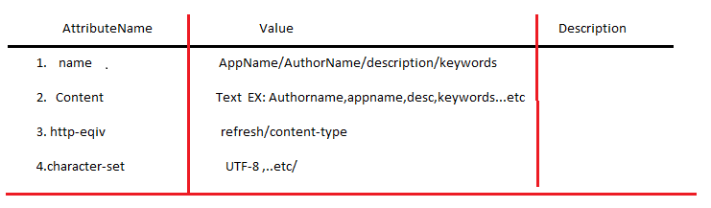

**6.1.b.Body**:- we define the elements in <body> tag . The elements will appear o web page.

**7)Creation and view Of Sample web page:-**

Step1:- Open Editor.

Step2:- Type the HTML Program.

Step3:- Save the file with .html extension or .htm extension.

Note:-1. Don’t use any spaces or special characters in file name.

2.A file extension is suffix of filename. It specifies type of file.

Step4:- Run the Html Program.

**Example**:-

<!DOCTYPE html>

<html lang="en">

<head>

    <meta charset="UTF-8">

    <title>Sample Web Page</title>

</head>

<body>

     This is First Sample web page.

</body>

</html>

Output:-

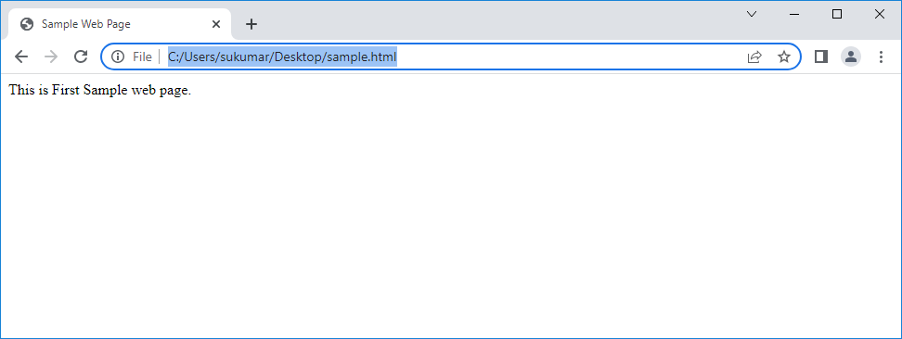

Note:-1.**Indentation** is a concept. It is giving space between left margin and line code. The indentation improves readability of code. The UI developer should follow indentation while writing the html programs. If developer follow this, others easily understand that what element is parent, what element is child.

**8. Inline and Block level Elements**: All the HTML Elements are been categorized into two types

I. Block Level Element

II. Inline Element.

8.1) Block level Elements: - Any HTML Element which comes under the block level category holds the following properties.

* + - It occupies 100% width of its container by default.
    - Even though it occupies 100% width we can still control the dimensions of the block level element through CSS width and height properties.
    - While getting rendered within the page by default it comes to new line and gets rendered.
    - The element which is following a block level element also automatically comes to a new line and gets rendered.

EX:- Paragraph tag

Heading Tags.

Division Tag.

List Tags.

…etc.

8.2)Inline Elements:-Any HTML Element comes under inline category holds following properties,

* + - While rendering on the page all the inline elements tries to render within the same line.
    - Inline elements always occupies the width within the container based on the content it is holding.
    - We cannot control the dimensions of an inline element.

EX:- span Tag.

**9.Paragraph Tag**:- It is used to define paragraph/multiline text on document. It can not contain another block-level element.

Syntax:- <p align=’left|right|center|justify’> content </p>

Where content is multiline text.

By default, text is left aligned.

While displaying the paragraph , browser adds one line before and one line after the paragraph.

Example:-

**10.Heading Tags:-**HTML has six levels of headings, which use the elements <h1>, <h2>, <h3>, <h4>, <h5>, and <h6>. While displaying any heading, browser adds one line before and one line after that heading. Header element h1 is considered the most significant header and is typically rendered in a larger font than the other five headers. Each successive header element is typically rendered in a progressively smaller font.

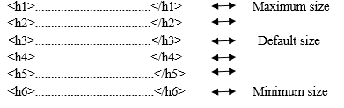

Example**:-**

**11. Horizantal Ruler:-** The <hr> tag displays horizontal line across the web page. Horizontal ruler tag is used to separate the content in an HTML document.

Syntax:-

<hr color=“ color name” align=“left/center/right” size=“value in percentage” width=“ value in percentage”>

Size specifies the thickness of line.

Example:-

<!DOCTYPE html>

<html lang="en">

<head>

    <meta charset="UTF-8">

    <meta http-equiv="X-UA-Compatible" content="IE=edge">

    <meta name="viewport" content="width=device-width, initial-scale=1.0">

    <title>HR TAG</title>

</head>

<body>

    <h1 align='center'>Family Memeber Names</h1>

    <p>sukumar</p>

    <hr color="green" size='1px' width='200px' align='left'>

    <p>Veena</p>

    <hr color='green' size='2px' width='300px' align='left'>

    <p>Sulamaha</p>

    <hr color='black' size='3px' width='400px' align='left'>

</body>

</html>

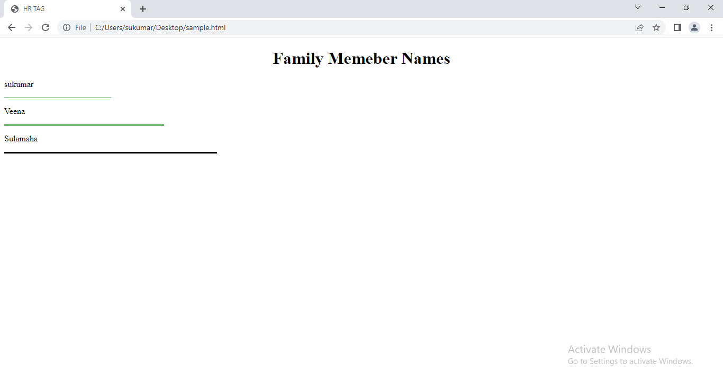

**12.Div Tag**:- This tag is used to divide the document into divisions or sections.

**Syntax**:- <div>

….

<div>

**13. Span Tag**:-The <span> tag is an inline container used to mark up a part of a text, or a part of a document.

Syntax:- <span> content </span>

**Example**:-

<!DOCTYPE html>

<html lang="en">

<head>

    <meta charset="UTF-8">

    <title>SPAN TAG</title>

</head>

<body>

   <h1> I Believes that <span style='background-color: blue;'>Satyameva Jayathe</span></h1>

</body>

</html>

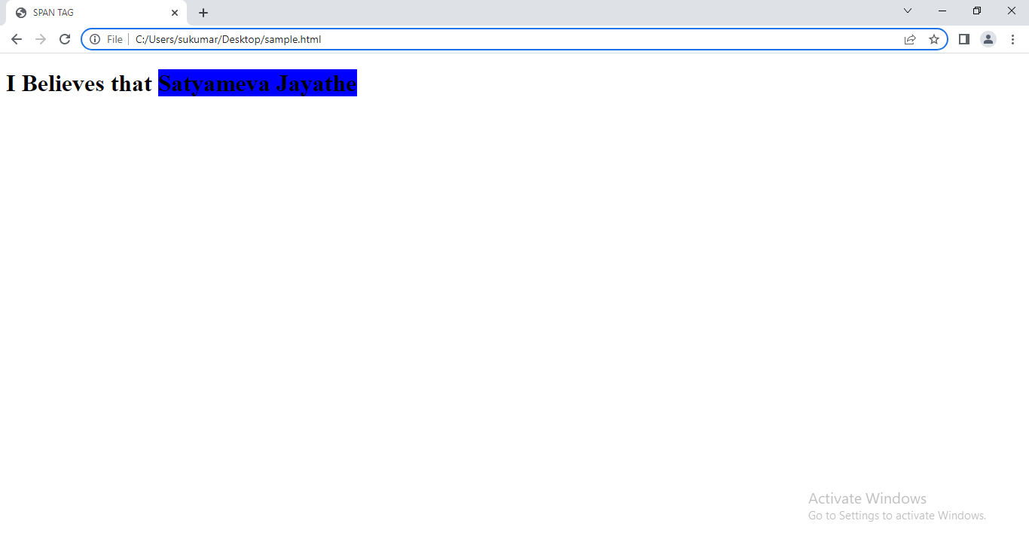

**14. Image Tag:-** The <img> tag creates a holding space for the referenced image. In that space , Images are linked to web pages.

**Syntax**:-

<img src=’Address of image file’ height=’value1’ width=’value2’>

The Address of image file is either absolute path name (or) Relative path name.

Example:-

<!DOCTYPE html>

<html lang="en">

<head>

    <meta charset="UTF-8">

    <title>IMAGE TAG</title>

</head>

<body>

    <div>

        <img src='file:///E:/Photos/suku%20veena%20grand%20world/DSC01003.JPG'  height='250px' width='300px'>

    </div>

    <div>

        <img src='file:///E:/Photos/suku%20veena%20grand%20world/DSC01010.JPG'  height='250px' width='300px'>

    </div>

</body>

</html>

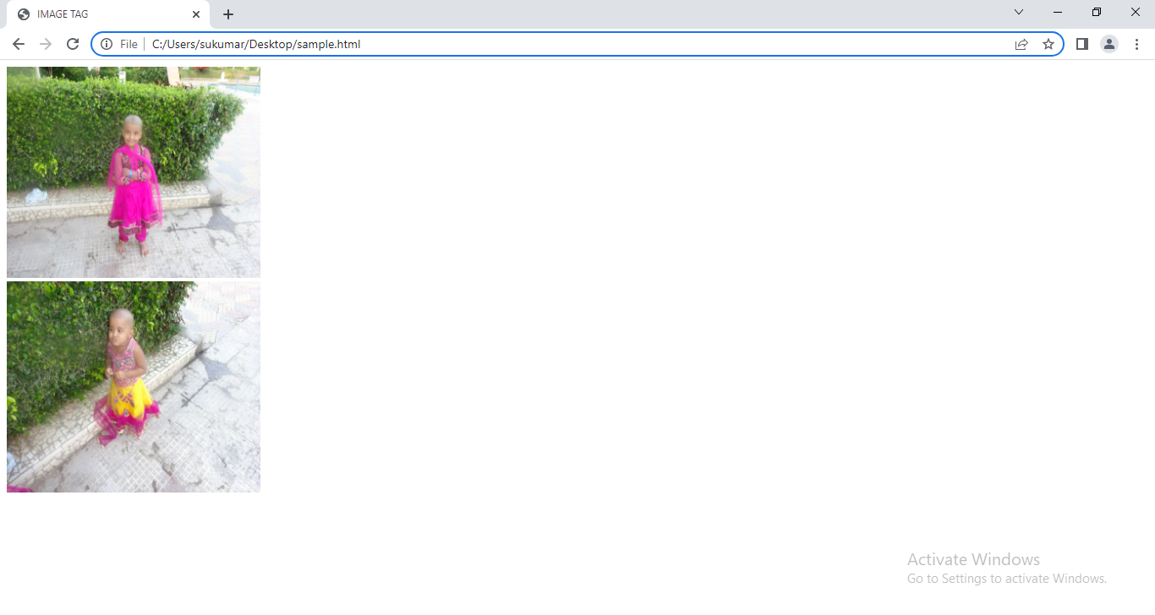

**15. Hyper Link**:- Hyper Link is unidirectional pointer from current document to destination. The destination may be in same document, another document which may be in same website or another document which may be in another website.

The anchor tag is used to establish a link between web pages.

**Syntax:**

<a href=’Address of html file’ [name=’v1’ accesskey=’v2’ download=’v3’ target=’v4’ rel=’v5’ rev=’v6’]> Content </a>

Where content is text or image.When cursor is placed on text or image, cursor appears differently. If we don’t visit the destination then content(text/image border) will appear in blue. Once we visit the destination then content(text/image border) appear in purple color.The text will be underlined on webpage. When content is pressed with mouse and release, In between these two actions content is in red color and that is active state.

**Attributes:**

1.Name:- we name the anchor so name can be used as value of href of another anchor. Using this, we move from one location to another location within same document.

2. Accesskey:- The link is activated with the combination of the accelerator key, usually ALT, and the key specified by the attribute.

3.rel:- It specifies relation b/w current document and destination document.

4.rev:- It specifies relation b/w destination document and current document.

5.download:- When user clicks anchor , the destination file will be downloaded into local machine.

6.target:- It specifies where to open the destination document.

Values are _blank ,_self ,_parent ,_top , frame name .

_blank: opens the linked document in a new window or tab.

_self: opens the linked document in the same frame or window/tab as it was clicked.(this is default value).

_parent: opens the linked document in the parent **Frame**.

_top: opens the linked document in the full body of the window.

Framename: opens the linked document in the named iframe.

Ex:-

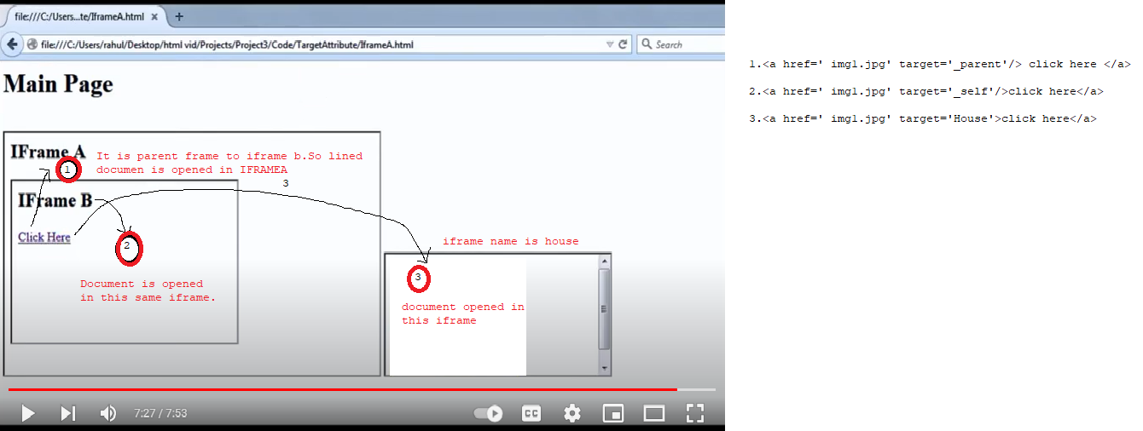

15.1) Types of Hyper Links:-There are four types of hyperlinks in HTML . They are:

A. Internal Hyperlinks

B. External Hyperlinks

C. Image Hyperlinks

D. Mailto Hyperlinks

**A.INTERNAL HYPERLINKS:-**It creates a link from one position to another position with in the same webpage. Here we create source and target.

***Syntax:***

At source: <a href=“#linkname>Content</a>

At target: <a name=“linkname”>Content</a>

Example:

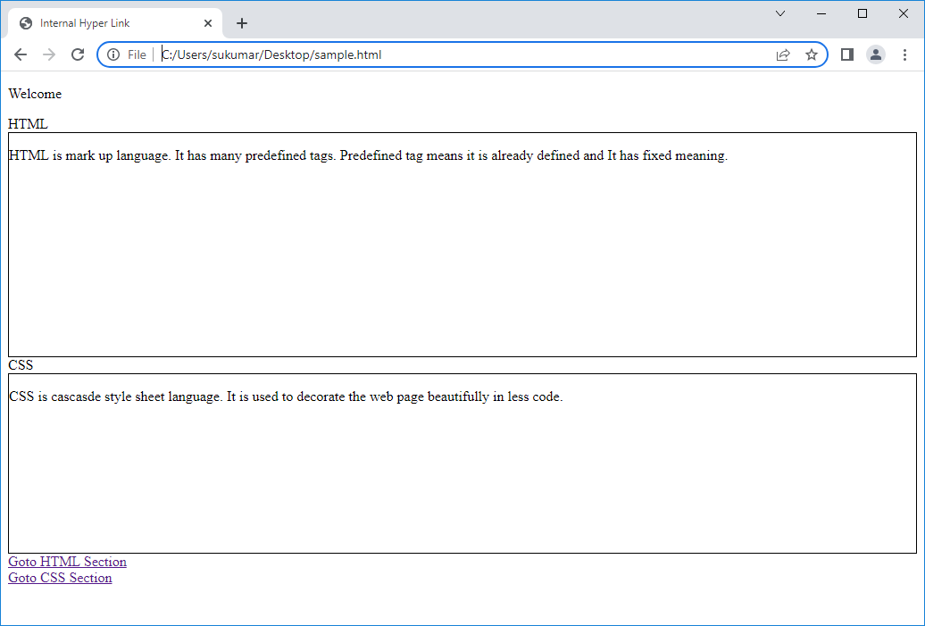

**B**.**EXTERNAL HYPERLINKS:** It creates a link between different webpages or websites.

**Syntax:** <a href=“url”>diplay text </a>

Example:-

<!DOCTYPE html>

<html lang="en">

<head>

    <meta charset="UTF-8">

    <meta http-equiv="X-UA-Compatible" content="IE=edge">

    <meta name="viewport" content="width=device-width, initial-scale=1.0">

    <title>External Hyper Link</title>

</head>

<body>

    <h1 align='center'>External HyperLink</h1>

   <div><a href='www.google.com'>Open Google Website</a></div>

   <div><a href='file:///E:/Photos/suku%20veena%20grand%20world/DSC01010.JPG' download='true' target='blank'>DownLoad the MyKID Image</a></div>

   <div><a href='www.meeshow.com' target='blank'>Open MeeShow Website</a></div>

</body>

</html>

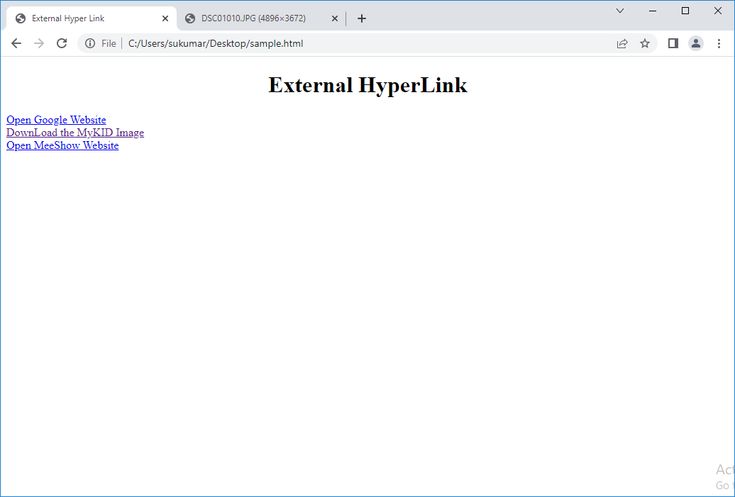

**C.IMAGE HYPERLINKS:** It creates a image hyperlink . When we click on image, it will open the webpage that is associated with the image.

**Syntax:** <a href=“image.html”><img src=“url”>diplay text </a>

Example:-

<!DOCTYPE html>

<html lang="en">

<head>

    <meta charset="UTF-8">

    <meta http-equiv="X-UA-Compatible" content="IE=edge">

    <meta name="viewport" content="width=device-width, initial-scale=1.0">

    <title>Image Hyper Link</title>

</head>

<body>

   <h1 align='center'>Image HyperLink</h1>

   <div><a href='www.google.com' target='blank' title='Click to open google web site'><img src='file:///E:/Photos/suku%20veena%20grand%20world/DSC01010.JPG' height='200px' width='200px'></a></div>

 </body>

</html>

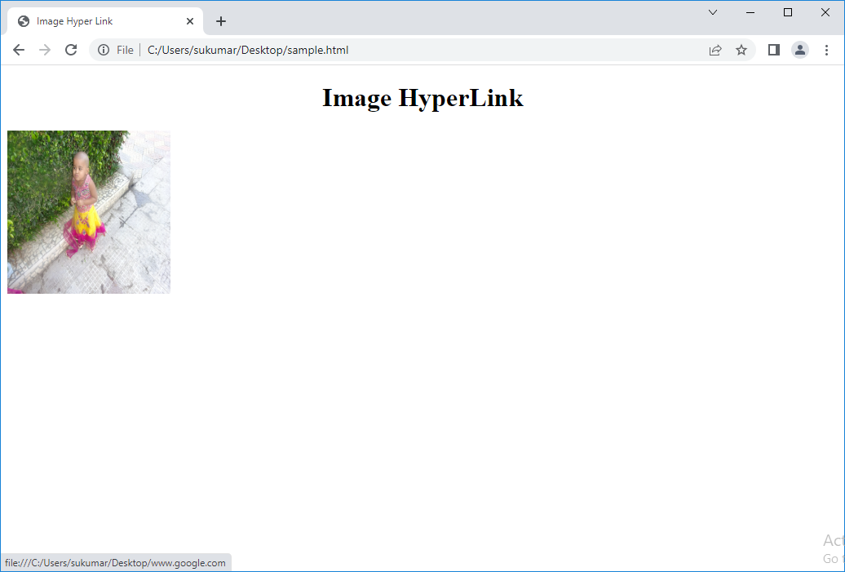

**D.MAILTO HYPERLINK:** It is special type of hyperlink. It contains e-mail address.

**Syntax:** <a href=“mailto:email address”>Email address</a>

15.2.<nav>-:- when you place anchor tage inside <nav> , the some space is left between any two adjacent anchor elements.

Example:

<body>

    <nav>

    <a href="">one</a>

    <a href="">two</a>

    <a href="">three</a>

    <a href="">four</a>

    </nav>

</body>

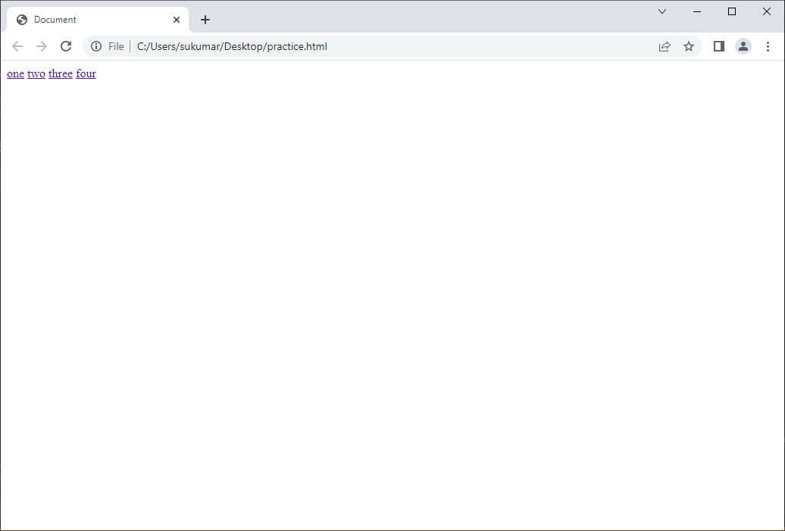

**16.LIST:-**List is group items. There are 3 types of lists in html5.

* Ordered list
* Un ordered list
* Description list.
* Nested List.

1. Ordered List:- If order of list items is important and we should not neglect order of list items then we creates Ordered list.

Syntax:-<ol type=’1|A|a|I|I’ >list items </ol>

The defalt marker is ‘1’.

Example:-

<!DOCTYPE html>

<html lang="en">

<head>

    <meta charset="UTF-8">

    <meta http-equiv="X-UA-Compatible" content="IE=edge">

    <meta name="viewport" content="width=device-width, initial-scale=1.0">

    <title>Ordered List</title>

</head>

<body>

    <ol  type='circle'>The following list has 6 items. We have to learn courses in the following order.

        <li>HTML</li>

        <li>HTML5</li>

        <li>CSS</li>

        <li>CSS3</li>

        <li>Js</li>

        <li>BootStrap</li>

    </ol>

</body>

</html>

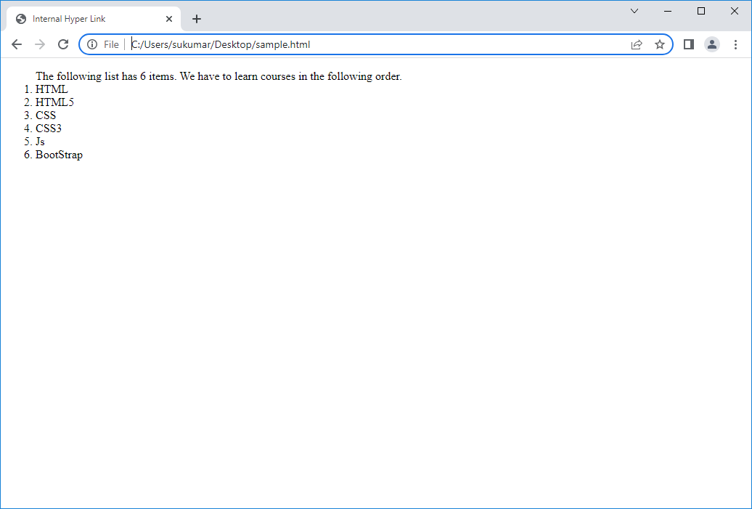

B)UnOrdered List:- If order of list item is not mandatory, then we create Un ordered list.

Syntax:-<ul type=’disc|circle|square’>listitems</ul>

The disc,circle and square are called list item markers.

Default list item marker is ‘disc’.

Example:-

<!DOCTYPE html>

<html lang="en">

<head>

    <meta charset="UTF-8">

    <meta http-equiv="X-UA-Compatible" content="IE=edge">

    <meta name="viewport" content="width=device-width, initial-scale=1.0">

    <title>Un Ordered List</title>

</head>

<body>

    <ul  type='circle'>The following list has 4 items. We can learn courses in any order.

        <li>Operating System</li>

        <li>Database Systems</li>

        <li>Programming Language(java/python)</li>

        <li>Front-End Technologies</li>

    </ul>

</body>

</html>

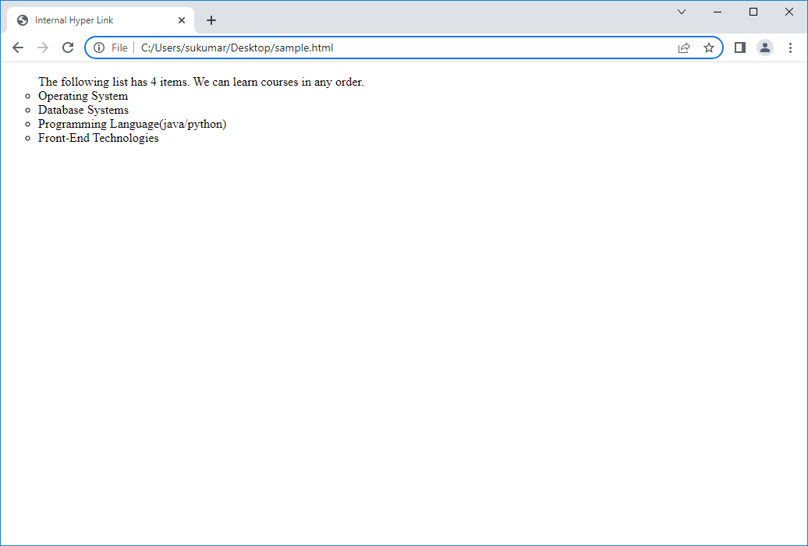

c)Description list:- It is collection of list items. Description has definition for each list item.

<dl>..</dl> :- It Is used to create description list.

<dt>..</dt> : - This tag is used to define the list item.

<dd>..</dd> :- This tag is used to define the definition of list item.

Example:

<!DOCTYPE html>

<html lang="en">

<head>

    <meta charset="UTF-8">

    <title>Description List</title>

</head>

<body>

    <h2 align='center'>Description List</h2>

    <dl>

        <dt>HTML:</dt>

        <dd>Hyper textmarkup language. It is used to design the webpages.</dd>

        <dt>CSS:</dt>

        <dd>Cascade style sheet which is used to  beautify the elements in webpage</dd>

        <dt>JS:</dt>

        <dd>Java script .It is used to interact with webpage dynamically.</dd>

   </dl>

</body>

</html>

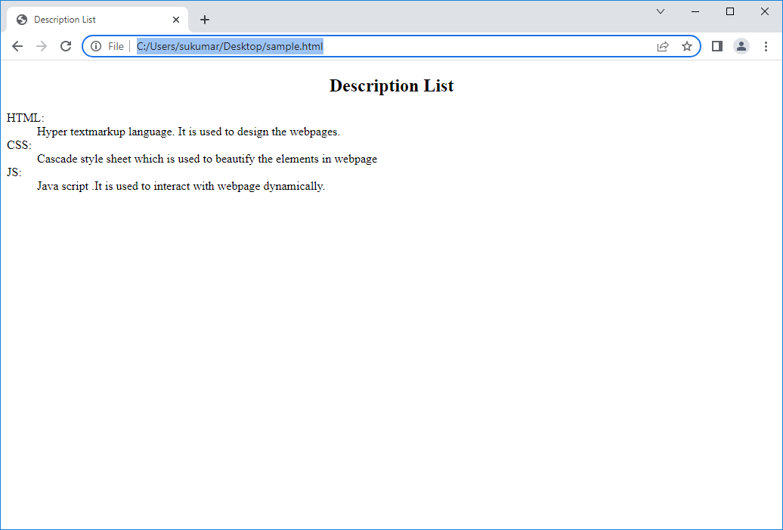

***d.Nested List:*** A list contains another list is known as Nested list. By using this feature we can present a list and sublist on the web page. The Inner List can be in any <li> tag.

<ol/ul>

<li>............</li>

<li>...........</li>

<li>

<ul>

<li>.....</li>

<li>......</li>

..............

...................

</ul>

</li>

....................................

.....................................

</ol/ul>

Example:-

<!DOCTYPE html>

<html lang="en">

<head>

    <meta charset="UTF-8">

    <meta http-equiv="X-UA-Compatible" content="IE=edge">

    <meta name="viewport" content="width=device-width, initial-scale=1.0">

    <title>Nested List</title>

</head>

<body>

    <h2 align='center'>Nested List</h2>

    <ol>

        <li>Front End webTechnologies.

            <ol>

                <li>HTML4.</li>

                <li>CSS2.</li>

                <li>Core Java Script.</li>

            </ol>

        </li>

        <li>Back End technologies.

            <ol>

                <li>NodeJs</li>

                <li>Oracle</li>

            </ol>

        </li>

    </ol>

</body>

</html>

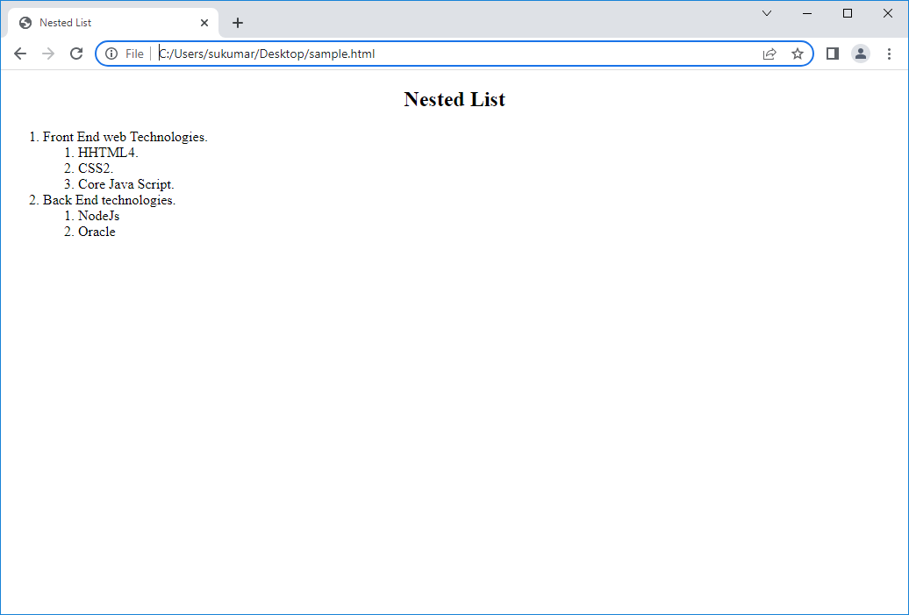

**17.Table:-**

* + - It is used to organize data and display data in rows and columns.
    - Later, table is used to design web page layout.

17.1.**FOR display and organising data**:-

1) <table>:- This tag is used to create table. It is like inline-table (i.e) by default it occupies width & height as it requires. But we can explicitly set width and height of table.

Syntax:

<table align=’left|right|center’ valign=’middle’ border=’1|0> …</table>

By default, table alignment is left alignment.

2)<tr>: This tag add row to table.

Syntax:

<tralign=’left|right|center’ valign=’middle|bottom|top’>…</tr>

* + - We can’t explicitly set width and height of row.
    - It occupies available width of table. If row has more than one cell and we don’t explicitly set height & width of <th>and< td>,then width is equally distributed among cells.
    - It occupies available height of table. If table has more than one row and we don’t explicitly set height of <th>and< td>, then height is equally distributed among cells.

3.<th> : This tag add table heading cell to row.

Syntax:

<th align=’left|right|center’valign=’top|middle|bottom’>sukumar</th>

Default horizontal alignment is ‘center’.

Default vertical alignment is ‘middle’.

4.<td>: This tag add table data cell to row.

Syntax:

<td align=’left|right|center’valign=’top|middle|bottom’>sukumar</td>

Default horizontal alignment is ‘left.’

Default vertical alignment is ‘middle’.

The height and width ofcells(td,th) can explicitly be set by us.Otherwise they equally shares width of <tr>.

5)<caption>: -It is used to create caption of table. The caption can be top of table or bottom or table.

Syntax:-<caption align=’left|right|center’>….</caption>

Example:

<!DOCTYPE html>

<html lang="en">

<head>

    <meta charset="UTF-8">

    <meta http-equiv="X-UA-Compatible" content="IE=edge">

    <meta name="viewport" content="width=device-width, initial-scale=1.0">

    <title>Table</title>

</head>

<body>

    <table border='2px' align='center'>

        <caption align='center'>Emp Details</caption>

        <tr>

            <th>SNo </th>

            <th>Name </th>

            <th>Age </th>

            <th>Gender </th>

            <th>Present Address </th>

            <th>Permanent Address</th>

        </tr>

        <tr>

            <td>1</td>

            <td>Raj</td>

            <td>20</td>

            <td>Male</td>

            <td>Hyderabad</td>

            <td>Assam</td>

        </tr>

        <tr>

            <td>2</td>

            <td>Teena</td>

            <td>22</td>

            <td>Female</td>

            <td>Hyderabad</td>

            <td>Delhi</td>

        </tr>

        <tr>

            <td>3</td>

            <td>Meena</td>

            <td>21</td>

            <td>Female</td>

            <td>Hyderabad</td>

            <td>Rajastan</td>

        </tr>

        <tr>

            <td>4</td>

            <td>Sachin</td>

            <td>25</td>

            <td>Male</td>

            <td>Vijayawada</td>

            <td>Vijayawada</td>

        </tr>

    </table>

</body>

</html>

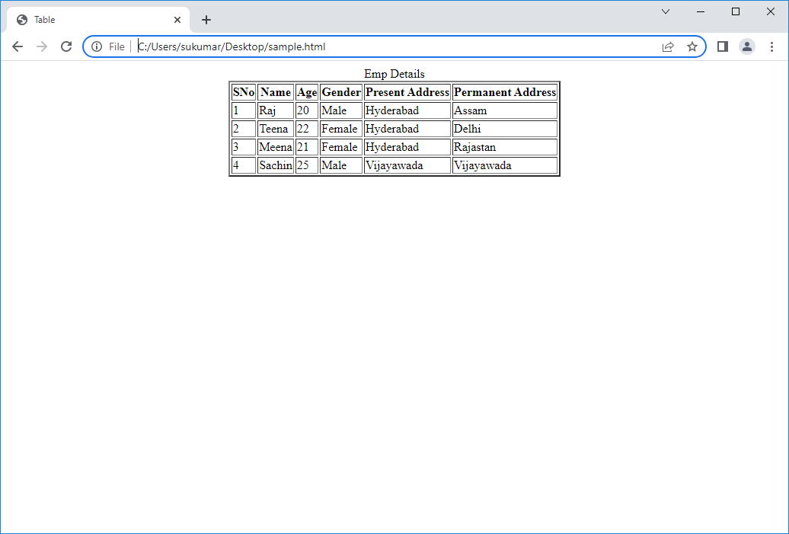

17.2. For web Page Layout:-

To design web page layout ,we use following four attributes in <th>,<td> tags.

1. rowspan:- It allows a cell to span height of more than one cell or row.

2. colspan :- It allows a cell to span width of more than one cell or column.

3. cellspacing:- It is used to add space between two adjacent cells.

4. cellpadding:- it is used to add space between cell border and its content.

Example:

<!DOCTYPE html>

<html lang="en">

<head>

    <meta charset="UTF-8">

    <meta http-equiv="X-UA-Compatible" content="IE=edge">

    <meta name="viewport" content="width=device-width, initial-scale=1.0">

    <title>Table</title>

</head>

<body>

    <table border='2px' align='center' cellpadding='2px' cellspacing='1px'>

        <caption align='center'>Emp Details</caption>

        <tr>

            <th>SNo </th>

            <th>Name </th>

            <th>Age </th>

            <th>Gender </th>

            <th>Present Address </th>

            <th>Permanent Address</th>

        </tr>

        <tr>

            <td>1</td>

            <td>Raj</td>

            <td>20</td>

            <td>Male</td>

            <td rowspan='3'>Hyderabad</td>

            <td>Assam</td>

        </tr>

        <tr>

            <td>2</td>

            <td>Teena</td>

            <td>22</td>

            <td>Female</td>

            <td>Delhi</td>

        </tr>

        <tr>

            <td>3</td>

            <td>Meena</td>

            <td>21</td>

            <td>Female</td>

            <td>Rajastan</td>

        </tr>

        <tr>

            <td>4</td>

            <td>Sachin</td>

            <td>25</td>

            <td>Male</td>

            <td colspan="2">Vijayawada</td>

        </tr>

    </table>

</body>

</html>

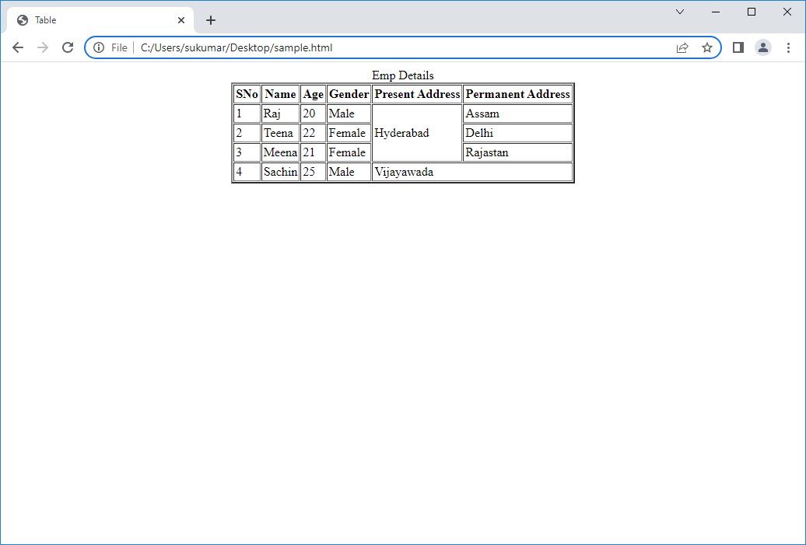

1. <thead>:

* This tag is used to group header content in html table.
* This tag must be before the <tbody>,<tfooter> and any <tr> tag.
* This tag must be after the <caption> tag. It should has at least one <tr> tag.
* It is used to style the related table headings differently from table body and table footer.

1. <tbody>:

* This tag is used to group body content in html table.
* It must has at least one <tr> tag.
* It is used to style the table data headings differently from table headings and table footer.

1. <tfooter>:

* This tag is used to group footer content in html table.
* It must has at least one <tr> tag.
* It is used to style the table footer differently from table headings and table body.

Note:-Browsers can use above 3 elements to enable scrolling of the table body independently of the header and footer. Also, when printing a large table that spans multiple pages, these elements can enable the table header and footer to be printed at the top and bottom of each page.

We can also define the table using <div> tag.

Example:

<!DOCTYPE html>

<head>

    <meta charset="UTF-8">

    <title>Float property</title>

    <style>

        .stu_row

        {

            height:20px;

            width:300px;

        }

        .stu_row > div

        {

            border:1px solid green;

            float:left;

            height:20px;

            width:100px;

            text-align:center;

            box-sizing: border-box;

        }

    </style>

</head>

<body>

    <div class='stu_table'>

        <div class='stu_row'>

            <div>SNO</div>

            <div>SNAME</div>

            <div>AGE</div>

        </div>

        <div class='stu_row'>

            <div>1</div>

            <div>suku</div>

            <div>41</div>

        </div>

        <div class='stu_row'>

            <div>2</div>

            <div>veena</div>

            <div>38</div>

        </div>

    </div>

</body>

</html>

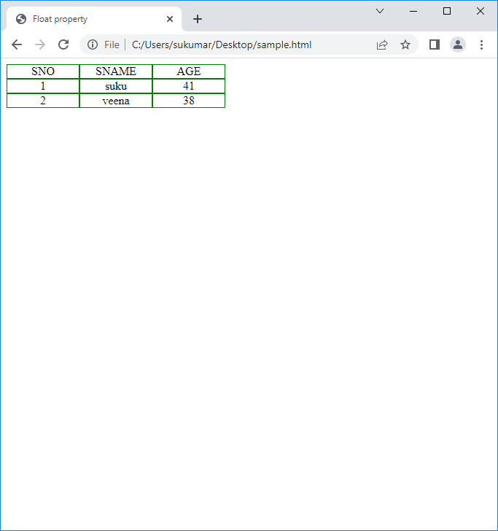

The same table can also be created using <table> tag. Where as what is difference?

When table is defined by <table> tag, Browser needs more time to render this element. Because browser has to check <table>tag has <tr> tag or not and browser has to check <tr> tag has <td/th> tag or not. For checking , more time is taken.

When table is defined by <div> tag, Browser renders this element in less time.

**18. HTML Input Elements**:- The following are pre-defined HTML input elements. They can read the different types of data from user. All input elements are inline elements.

**18.1)Input:-**

Syntax:-<input attributes/>

Attributes:

1. type:- It store input element name. The element name are text,password,checkbox,radio,button,image,file,search,url,date,time,month,day,year,number,range,color ,email and datetime.
2. Align: values are left,right,top,middle,bottom.
3. Disabled: values are true or false.
4. Name:- It represents name of input control.
5. Value:- It specifies text. If assign value to input control at input control definition, then value will appear in element.

Otherwise when we enter value on form,the value will be assigned to input control.

1. Readonly:- It specifies input field is read only element. It will not accept value from user.
2. Maxlength:- It specifies maximum no.of character allowed in text element.
3. Required:- If required element is empty or invalid,then form will fail to submit and first invalid required element get focus.
4. Placeholder:- It specifies ‘short hint ‘ inside the input element. When input element get focus, ‘shot hint’ will appear.

When input element lost focus , ‘shot hint’ will reappear.

1. Multiple:- The input element allows multiple values. This is used for email,url,file…etc.
2. Autofocus:- It stores either true or false.

If it is true, the input element automatically gets focus after loading form.

1. Min and max:- It is used for number ,range,date,time,datetime,month,day,week .
2. Autocomplete:- its value is on or off.
3. List:- This attribute store id of <datalist> tag.
4. Step :- It specifies legal number intervals for <input> elements. It is used along with <number>,<range>,<date>,<time>,

<month>,<week>..

1. Form:- This attributes specifies one or more forms on <input> element belongs to.

Note:- To refer to more than one form, use space –separated list of form ids.

17.novalidate:-

18.2)<textarea>:-It is block level element. It collects multiline input from the user.

Syntax:

<textarea> content|empty </textarea>

Note:- browser displays text area with default measurements. Later we can directly modify height and width of text area on webpage.

18.3) option:- It defines the options . This tag is placed inside the <select> and <datalist> tag.

Syntax: <option attr=’val’ > content </content>

a) disabled.

b) selected: Specifies that options should be pre-selected when page loads.

c) value:- It specifies value to be sent to server.

18.4)<optgroup>:- It is used to group the related options in drop-down list.

Syntax: <optgroup disabled>

<option>..</option>

<option>..</option>

</optgroup>

18.5)Select:- It is used to create the drop-down list.

Syntax: <select attr[s]>

<option>..</option>

<option>..</option>

</select>

a)disabled

b)multiple:-The use can select the multiple options.

c)size:- It specify the no.of visible options in drop-down list.

d)name.

18.6)label:- It defines label for an <input> element. A label can be bound to <input> element either by using **“for”** attribute or by placing element in side <label> element.

Syntax:

<label for=”element-id”> Content </label>

18.7)fieldset:-It is used to group the input related items in a form. This tag draws box around the input elements.

18.8)legend:- It defines caption for <fieldset> element.

Syntax:-<legend align=’left|right|bottom|top’> caption</legend>

Note:-1.<fieldset> is block-level element.

2.<select>,<option> and <optgroup>are inline-level element.

3.<label> and <legend> is also inline element.

6.10)meter:- It is also known as ‘guage’. It defines measurement with in range.

Syntax:<meter attr[s]>content</meter>

Attributes:

a)min: It specifies minimum value of range.

b)max:It specifies maximum value of range.

c)low: It is value where guage value is considered as low value.

d)high: It is value where guage value is considered as high value.

e)value:It represent the current value.

Ex: Disk space Uage , % of voting.

**19.Form Tag**:-A predefined tag using which we could able to send user input data to the server. It takes the following mandatories i.e. method and action.

A) METHOD attribute used to which we could specify the type of the communication while sending or receiving the data.

B) ACTION attribute used for through which we specify the path of the server to which communication should happen.

Ex: <form action=”server url” method=”get/post”> ……… ……… </form>

Note:- If any input element does not has name and value attribute then when we press submit button, form does not consider such input elements and remaining element name and current value is given to server by the form.

**➢ Types of Communication:** While communicating with a server, it could be either secured or nonsecured type of communication.

**• Non-Secured type of Communication (GET):** In this type of communication the data will be sent to the server by appending to the URL as queryparameters.

**Ex:** [**http://www.abc.com/data/user/info?uname=test&age=20**](http://www.abc.com/data/user/info?uname=test&age=20)**....**

**• Secured Communication(POST**): In this type of communication the data will be sent to the server by adding it to the request header which is not exposed to the end user. Any time we send sensitive data to the server we use POST type of communication.

**Example:**

<html>

    <head>

    <title>student Registration Form</title>

    </head>

    <h1 align="center">Registration Form</h1>

    <hr align="center" size="20%" width="30%" color="red">

    <body bgcolor="blue">

    <form>

    <p align="center">

    <fieldset>

    <legend>Core Details</legend>

    <label for='one'>Enter name</label> &nbsp &nbsp &nbsp &nbsp &nbsp &nbsp

    <input type="textbox" name="tb1" id="one"><br><br>

    <label for="two">Enter Father's name</label>

    <input type="textbox" name="tb2" id="two"><br><br>

    Enter password: &nbsp &nbsp <input type="password"><br><br>

    </fieldset><br><br>

    select gender:<input type="radio" name="r1">

    Male &nbsp &nbsp &nbsp

    &nbsp &nbsp &nbsp

    <input type="radio" name="r1">

    Female<br><br>

    select hobbies

    <input type="checkbox" name="cb1"> singing

    &nbsp &nbsp &nbsp &nbsp &nbsp &nbsp

    <input type="checkbox" name="cb2" >

     dancing<br><br>

    Select Qualification

    <select >

    <option>ssc</option>

    <option>Inter</option>

    <option> degree</option>

    <option>pg</option>

    </select><br><br>

    Describe ur self

    <textarea name="ta" rows="10" cols="20">

    </textarea><br><br>

    <input type="submit" value="Submit"> &nbsp &nbsp &nbsp &nbsp

    &nbsp &nbsp <input type="reset" value="Reset">

    </p>

    </form>

    </body>

    </html>

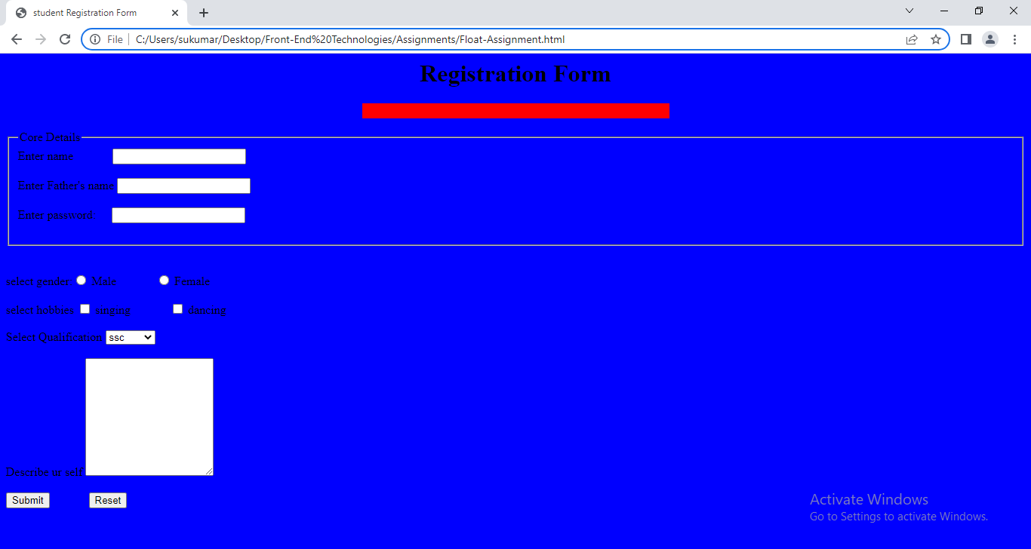

**20.***HTML special characters:*

Characters with special meaning in HTML are called reserved characters. For example, left (<) and right (>) angle brackets are reserved in HTML to identify the opening and closing tags of elements.

Characters that don’t appear on your keyboard include things like the copyright symbol (©) and the mathematical value pi(π) .

If we want to display such characters on webpage, then we should use eigther character entity code or chactacter enttity name in html program.

Example:

&character entity code or &#character entity name

|  |  |  |
| --- | --- | --- |
| **ENTITY NAME** | **DESCRIPTION** | **RESULT** |
| &lt | Less than | **<** |
| &gt | Greater than | **>** |
| &amp | Ampersand | **&** |
| &quot | Double quotations | **“** |
| &apos; | Single quotation | **‘** |
| &nbsp | Non breakable space | **Empty space** |
| &cent | cent | **₵** |
| &yen | yen | **¥** |
| &copy | copy | **©** |
| &reg | Registered trade mark | **®** |